COMPANY’S NAME
COMPANY REGISTRATION NO
ADDRESS
TEL / FAX
EMAIL ADDRESS

TRANSPORTATION EMERGENCY RESPONSE PLAN FOR
TRANSPORTATION OF HAZARDOUS SUBSTANCES / EXPLOSIVE PRECURSORS WITHIN SINGAPORE

PERPARED BY:

NAME : _____________________________________________
NRIC NO:____________________________________________
COMPANY REGISTRATION NO.: _________________________
DATE:_______________________________________________

SIGNATURE: _____________ COMPANY STAMP: __________

Contents Page

Contents Page 1

Schedule of Clearance* 2

Summary Table of Chemicals Transported 3

Main Plan 4

Situation x
(a) Introduction
- Areas of Operations
- Vehicle/Tanker/Container Description
- Hazard and Risk Assessment

Aim x

Execution x
- Concept of Operation
- Action by the Transport Company/personnel
during emergency
- Grouping and Tasks
- Co-ordinating Instructions

Service Support x
- Equipment
- Manpower

Command and Signal x
- Command
- Signal

6 Annexes x
Annex A – Routes of transportation (Highlighted Singapore Map)
Annex B – Summary Table of Hazardous Chemical Transported
Annex C – Product/Chemical MSDS / ^SDS
Annex D –Tables of Grouping & Tasks
Annex E – Valid Hazardous Material Driver Permit
Annex F – Table of Approved Vehicle / Container/ Tanker No.
Annex G – Other information including descriptions of Container/Tanker
Annex H – Photo of Approved Vehicles (showing front, side & rear of the
vehicles)

* Schedule of Clearance is referring to
(i) License, permit & approval issued by various government agencies such as SCDF, NEA, MOH,
SPF, etc
(ii) Previous licence, permit & approval issued by various government agencies (if any)
^ SDS – All MSDS (for substances) will needed to be replaced with GHS SDS by 31 Dec 2011.
– All MSDS (for mixtures) will needed to be replaced with GHS SDS by 31 Dec 2013.

Schedule of Clearance

(Please attached all the license, permit & approval issued by various government agencies)

TRANSPORTATION EMERGENCY RESPONSE PLAN
TRANSPORTATION OF PETROLEUM & FLAMMABLE MATERIALS WITHIN SINGAPORE

- SITUATION

a Introduction

Write up of the purpose, products, method and frequency of the transportation activities and the various agencies involved in the operation.

b Area of Operations

(1) General

(a) Routes of Transportation

State the actual routes of transportation to be taken from the starting point to end of journey (Show route to be taken on map with high-lighter, attach Annex A).

Eg. Route to be taken during transportation:
PSA Port -> Telok Bangah Rd -> Pasir Panjang Rd -> etc

(b) Areas Surround Transport Route

Identify and descript the various neighbouring occupancies (such as highly populated residential or environmental sensitive areas) along the routes to be taken.

(c) Approved Transport Time

Approved Transport Time accordance to Fire Safety (Petroleum and Flammable Materials) Regulations

Eg: 0700 hrs to 1900 hrs daily

c Hazard & Risk Assessment

(1) Hazard of Product

Description of the Hazards of the products is being transported, such as the flammability, toxicity corrosiveness, radioactivity, etc. (Attach Summary Table of Product(s) transported & Material Safety Data Sheet (MSDS) / ^Safety Data Sheet (SDS), etc, under Annex B and Annex C).

^ SDS – All MSDS (for substances) will needed to be replaced with GHS SDS by 31 Dec 2011.
– All MSDS (for mixtures) will needed to be replaced with GHS SDS by 31 Dec 2013.

(2) Possible Scenarios

Develop various possible scenarios that may result from any mishap occurred during the transportation, such as gas leakage through valve, traffic accident without gas leakage or traffic accident involving gas leakage, etc. Identify the possible hazard zones and safety distances necessary for each chemical/product involved. (Listed out the distance of hot zone and warm zone)

Eg. Accident may happen during transportation, resulting in
chemical spillage from the 3 damaged drums and bags.
Most of the chemicals will cause severe burn to the skin,
eyes and irritation to the respiratory system.

The Possible hazard zone will be sectored into:
- Hot zone with radius 10m around the incident point
- Warm zone with radius 30 m from the hot zone

(3) Worst Case Scenario

To describe the worst case scenario that may develop from the above possible scenarios. The worst case scenario could take into account the areas of concern surrounding the route taken. (Listed out the distance of hot zone and warm zone)

d Vehicle / Tanker / Container Descriptions

(1) Design of the vehicle / Tanker / Container

The description of design and layout of the vehicle/tanker/container used for the transportation to include:-

(I) Diagram showing piping, valves, and other emergency features.

- Any licences or approvals from SCDF / NEA or other approving agencies on the used of the vehicle/tanker/container.
- Provide license plates, numbers and storage conditions of the chemical in the containers and tankers

Information may attached in Annex G

(2) Maintenance

Give details on the maintenance programme of the vehicle/tanker/container to ensure the vehicle is fit to be used for the transportation for the duration of the transportation.

Eg. Certificates by approved authorities (3rd party agencies
approved by NEA) Hydrostatic testing every 2.5 years

Information may attached in Annex G

(3) Emergency Information

Detail of emergency information or labelling as accordance with SS586 with Diagram.
[Attached in Annex G:
- Actual shape and size IMDG Classification signs for lorry, standard container vehicle
- Emergency Information Panel for ISO-tankers Annex G]

2 AIM

The aim of this emergency plan is to detail the various preventive measures and operational action that need to be taken by company/licence holder/driver, in case of a spillage, leak or fire during road transportation of hazardous chemicals.

3 EXECUTION

a Concept of Operation

(1) The emergency operation to be conducted in phases as follows :-

Phase Action

I Transportation personnel / escort party (if any) to carry out initial containment activities and alert the chemical company and SCDF (Call 995)/Police (Call 999).

II SCDF predetermined turnout response to the scene for containment and rescue activities.

III To conduct major operations for containment and minimise risks with other related agencies.

IV To clean up/decontaminate and resume normal operations.

(Clearly, state the parties that are responsible in the cleaning up the area after incident. The party’s company name, address, contact no. and contact person must be indicated under Phase IV of the operation)

b Emergency Actions by Transport Company/Driver/Escorting Personnel

Detail description on the emergency actions to be carried out by :-

(1) The transportation personnel/escort party when the emergency occurred; and

(2) The company (transport/chemical after being notified of the emergency.)

c Grouping and Tasks

See Annex D

d Co-ordinating Instructions

(1) Key Personnel Emergency Contact Numbers

The key personnel of the chemical or transportation company to be notified during emergency who can assist in providing technical information of the chemicals. They must be contactable during the time of the transportation. (Contact No. must include both the contact numbers during office hour and after office hour, eg individual Handphone / Pager or Home contact No.)

(2) Government/Other Related Organisations

The contact number of the government authorities such as SCDF, Singapore Police Force, National Environment Agency, etc for any emergency.

Note: NEA contact no. is 67319670

(3) Sectorization

The incident site will be sectorised into HOT, WARM and COLD zone during emergency. The definition of the various zones are as follows :-

Hot Zone – This is the area around the incident
vehicle/tanker/container that required all personnel entering to be fully protected by means of BA sets and proper protective clothing and to be decontaminated upon leaving the zone.

Warm Zone – This is the area directly outside Hot Zone. All
personnel in this zone should be equipped with Breathing Apparatus and if situation requires, done the mask for full protection against toxic hazard gases.

Cold Zone – This is a non-hazard zone outside the Warm
Zone.

(4) Reporting / Alerting SCDF

The message to be used to activate SCDF and Police Force during emergency shall include the following information :-

(a) Location of the incidents.

(b) Type of incident.

(c) Chemical involved.

(d) Leakage with or without fire.

(e) Transport company and chemical company name and contact number.

(f) Casualties involved.

(5) Safety

Details of the safety measures to be taken by the transportation company to prevent any mishap and minimise any possible risk of the transportation before and during the transportation.

- SERVICE SUPPORT

a Equipment

(1) The list of fire protection equipment fixed or portable available in the transportation vehicle/tanker/container or escort party.

(2) Specialized equipment to be provided by the company in Singapore during emergency (the quantity and the time for mobilised to site.

(3) Medical facilities available in the vehicle or back-up by the company.

b Manpower

Technical experts available to assist the SCDF to contain the emergency. (Their appointment and contact number).

- COMMAND AND SIGNAL

a Command

During the emergency, the transport personnel shall try all necessary action to contain the emergency. On arrival, SCDF shall takeover command of the operation with the support of the transport/chemical company.

b Signal

SCDF will set up the necessary communications facilities for the operations.

Annex A

Routes of Transportation

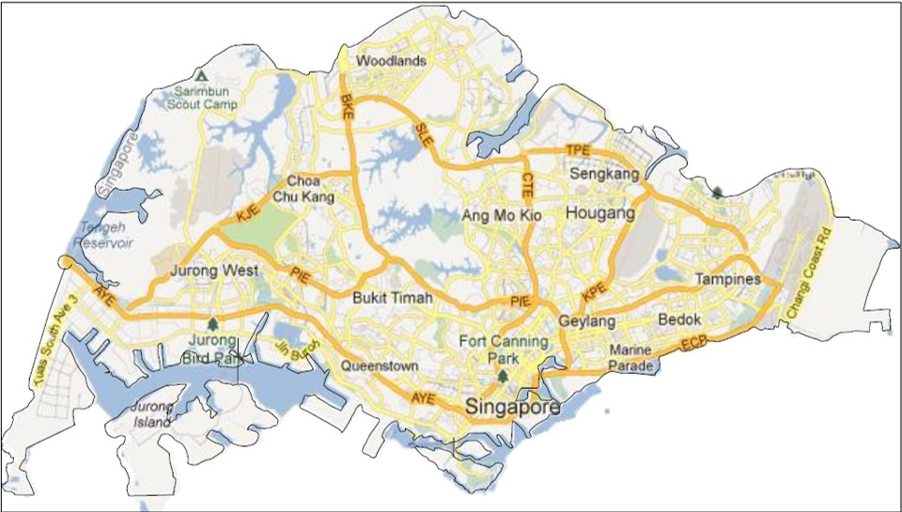

Annex B

Summary Table of Petroleum and Flammable Materials Transported

Summary Table of Chemicals Transported

S/no. | Chemical Name | IMDG Class | Type/Form | Max Approved Capacity transported per vehicle or container/per trip for import & export (via PSA Port, Tuas Link, Penjuru, Jurong Port or Changi Cargo Terminal (in kg or MT) | Max Approved Capacity transported per vehicle or container/per trip for local deliveries (if any please state location) to clients where applicable (in kg or MT) | Packing Type & Quantity per Packages
01 | Styrene Monomer | Class XX | Liquid | 20 MT from PSA | 20 MT to Tuas | 68kg/cyclinder
02
03
04
05
06
07
08
09
10

Note : Under IMDG class column, XX stands for the class no. from Class 1 to Class 9. To obtain the Class No., refer to
the supplier / MSDS of the chemical.

Annex C

Product / Chemical

Material Safety Data Sheet (MSDS) /
^Safety Data Sheet (SDS)

^ SDS – All MSDS (for substances) will needed to be replaced with GHS SDS by 31 Dec 2011.
– All MSDS (for mixtures) will needed to be replaced with GHS SDS by 31 Dec 2013.

1 One Set of the Material Safety Data Sheet (MSDS) / ^Safety Data Sheet (SDS) for each Product/Chemical are to accompany the submission.

2 The MSDS / ^SDS must be endorsed with original company’s stamp.

^ SDS – All MSDS (for substances) will needed to be replaced with GHS SDS by 31 Dec 2011.
– All MSDS (for mixtures) will needed to be replaced with GHS SDS by 31 Dec 2013.

Annex D

Table of Grouping & Tasks

S/NO | GROUPING | GENERAL TASKS | PHASE | DETAILED TASKS | REMARKS
1 | Driver/  Assistant/  Escort Party | a To carry out  Initial action to  contain the  leakage  b To alert SCDF &  transport  company.  c To minimise the  risk to people. | I | a) To Keep people away and control traffic flow.  b) To put off incipient fires using portable extinguishers.  c) To minimise spillage if possible.  d) To activate police/SCDF.  e) To contact the responsible company for the occurrence. | SCDF (call 995)  Police (call 999)  Key Personnel Nos:
1 | Driver/  Assistant/  Escort Party |  | II | To report to responding SCDF personnel to explain situation and provide assistance whenever possible.
1 | Driver/  Assistant/  Escort Party |  | III | To continue assisting SCDF.
1 | Driver/  Assistant/  Escort Party |  | IV | a) To recover vehicle/tanker/container.  b) To clear the incident site.

S/NO | GROUPING | GENERAL TASKS | PHASE | DETAILED TASKS | REMARKS
2 | Company  Technical  Expert/Response  Team | a To assist SCDF to  contain the  leakage/fire.  b To provide specialise advice and equipment (if any) to contain spillage/fire.  c To implement recovery activities when is under control. | I | Prepare all necessary equipment suitable (if any)  For the incident.
2 | Company  Technical  Expert/Response  Team |  | II | a) To proceed to the incident site on activation.  b) To report to SCDF personnel on site and give technical advice and other support.
2 | Company  Technical  Expert/Response  Team |  | III | Continue to assist SCDF in the operation.
2 | Company  Technical  Expert/Response  Team |  | IV | To carry out recovery and decontamination of the incident site. | Listed down the responsible company for the carry out process. Information required:  - Name of company  - Address of company  - Contact No. (office hour and after office)  - Contact Person

Annex E

Valid Hazardous Material Driver Permit(s) HDTP

Annex F

Table of Approved Vehicle / Container / Tanker Registration No.

Table of Approved Vehicle / Container/ Tanker used for transportation

S/N | Vehicle / Prime-over/Lorry |  |  | Trailer |  |  | Tanker / Lorry / Van / 20 or 40 footer Container |  |  |  | Storage condition of the Chemical
S/N | Reg No. | LTA Expiry Date | Owner’s Company | Reg No. | LTA Expiry Date | Owner’s Company | Type &  Reg No. | Expiry Date | Total Capacity | Owner’s Company | Name | Physical State | Storage Temp | Storage Pressure
1 | NAK 2610 | Nov 2004 | XYZ | T/N 2871 | Nov 2004 | XYZ | IMO 1  TPMU 141033-1 | Aug 2003 | Tanker  20000 litres | ABC | XXX | Liquid | 25°C | 6 bar
2 | YK 8111G | Dec 2003 | MNO | - | - | - | Lorry  YK 8111G | Dec 2003 | Cylinder  300 kg  (6 cylinders) | MNO | LPG | Gas | 25°C | 1 bar
3
4
5

Note:
- For vehicle (lorry & van), fill in the registration plate no. at vehicle / Prime-over at the vehicle/Prime-over and tanker columns.
- Owner’s company refers to the owner of the prime-over, trailer or tanker. (It maybe the transporter company, licence holder company, etc)
3. In the event of unable to provide information on the container no., indicate the reasons in the column such as various shipping lines uses, etc.
4. For chemical (in drums and cylinders) stored in 20 / 40 ft container or lorry, indicate the normal room temperature and normal atmospheric pressure in the
appropriate “storage conditions of the chemical” columns. For chemical stored in ISO tanker / tanker, indicate the storage temperature and pressure in the ISO tanker / tanker in the appropriate “storage conditions of the chemical” columns.

Annex G

Other Information including Descriptions of Container / Tanker

Annex H

Photo of Approved Vehicles
(showing front, side & rear of the
vehicles)

Photo of Approved Vehicles (showing front, side & rear of the vehicles)

S/N | Vehicle Reg No | View
S/N | Vehicle Reg No | Front | Side | Rear
1 | AB1234Z | 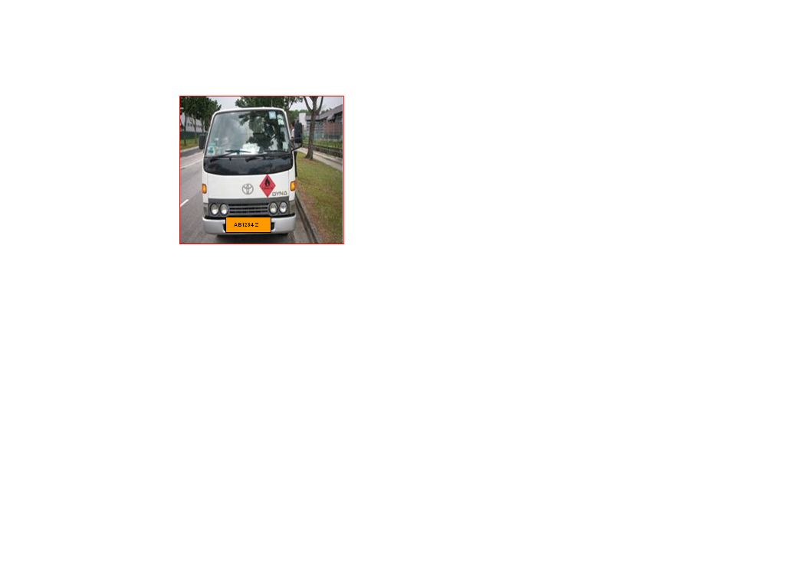  *Colour: White | 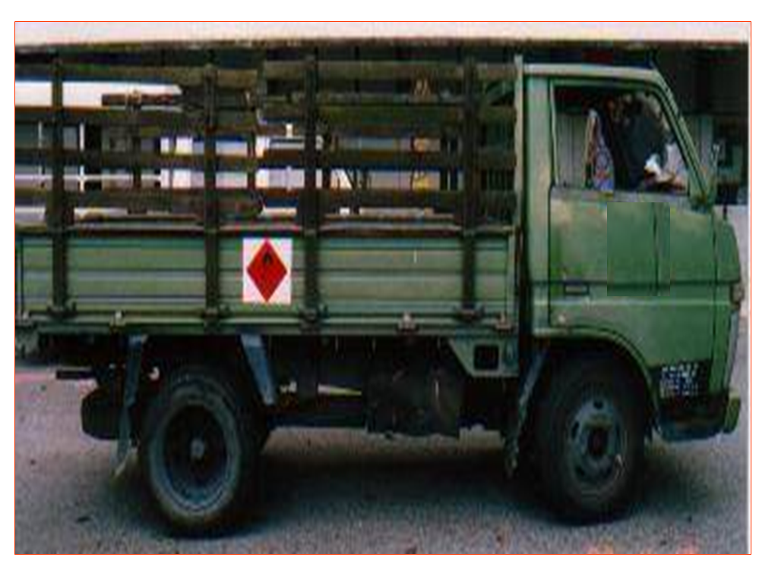  *Colour: Green | 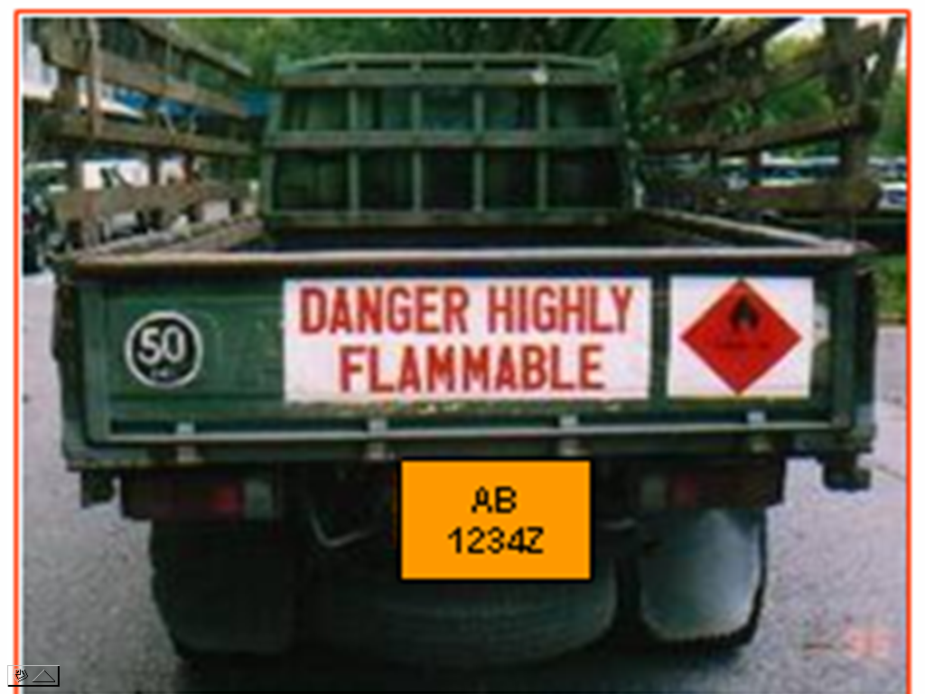  *Colour: Green

* Colour – Please indicate the colour of the front, side and rear of the vehicle, if the photo
submitted for the vehicle is non-coloured (or black & white)

